Lushan UNESCO Global Geopark Annual Report 2018

GEOPARK IDENTITY
Lushan UNESCO Global Geopark/China/APGN

Year of inscription / Year of the last revalidation: 2004/2018

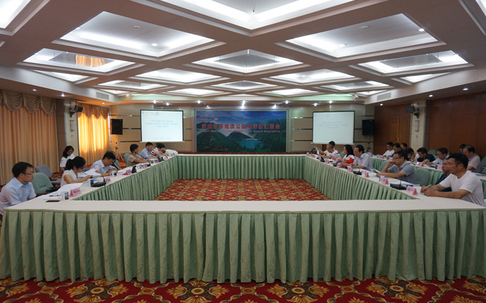
Lushan UNESCO Global Geopark Revalidation

GEOPARK FIGURES
Number of Geopark staffs: 1480 staffs including 5 geologists
Number of Visitors: 23，583，300 visitors person/time
Number of Geopark events: 28 times
1.Annual regular festival activities, such as during Bird-loving Week, World Earth Day, World Reading Day, World Environmental Day, International Disaster Reduction Day etc, students, communities residents and tourists involve in these activities; 2.On Chinese traditional festivals, the communities residents participate cultural and physical activities;3.Cooperated with schools, universities, the geopark held different activities like studying trips and summer camps; 4.Cooperated with local schools, museums, Lushan Protection Area Administrative Bureau, Lushan Botanic Garden, Jiujiang Love-nature Science Popularization Consulting Co., Ltd., the geopark set up various education projects, including local education, natural practice education, and museum second-classroom education for local community residents, elementary and middle school students; 5.Held regular special lectures and trainings for managers, interpreters, and enterprise executives; 6.Held geological, meteorological and other natural disaster emergency drills to promote better understanding and ensure the correct response by local community residents to disasters.
Number school classes realize Geopark educational programmes: 45
Number of Geopark press release: 4 articles, including one English article were released in China Global Geopark Net website，43 Chines and 22 English articles in Lushan UNESCO Global Geopark website and Wechat platform.

GEOPARK ACTIVITIES
Major achievements in 2018
- Lushan UGGP was approved with a Green Card by the UNESCO Global Geoparks Council in revalidation 2018. 2. Smart Lushan Platform was established and tourism service function was promoted; 3. the investigation on Lushan tourism resources was finished;4. a new geo-museum was built up and open to the public for free; 5.Tourism environmental renovation was completely carried out with the special fund; 6.The project of promoting the lighting system and public toilets was achieved; 7.Modification work of the highway from Lushan Tunnel to the South Road was finished.

Contribution towards GGN-Networking and Participation

1.Signed sister agreement with Jiuhuashan Geopark; 2.Participated International Workshop on Integration of Geo-landscape and Local Culture in Jiuhuashan Geopark; 3.Participated Revalidation Seminar of Chinese Global Geoparks; 4.Participated the 4th International Training Course on UNESCO Global Geoparks Management and Development; 5.Participated Annual conference of Chinese Global Geopark held in Yandangshan(presentation); 6. Participated the 8th International Conference on UNESCO Global Geoparks held in Italy; 7. Participated the Training Courses on Monitoring Application of Space Technology in the Geoparks held in Longyan Geopark; 8.Involved in the activities on World Earth Day, International Disaster Reduction Day，International Mountain Day with the requirement of the Global Geopark Networks;

Management:
- Management Structure：the geopark has established the Administration Management Office of Global Geopark ( World Heritage) to promote the management, conservation of the geopark, and monitor and early-warning for disasters specially.
2. Financial status: the revenue and expenditure of the geopark is in balance with some surplus. The 2018 fiscal revenue of the geopark is RMB 964.5587 million among which RMB 957.298 million is used in geopark management, conservation, construction, promoting tourism and sustainable economic development with the surplus of RMB 7,260,700.

Geoconservation:
Strictly abiding by Lushan National Geopark Master Plan 2013-2030, Lushan made geological heritage conservation at different levels and districts. The geological heritages of the geopark have been carefully and soundly conserved, and have remained unaffected by human destruction, and only few geosites influenced by natural weathering and meteorological disaster. The geopark investigated the geological heritages in the extended area of the geopark when the geopark was extending the coverage under the requirement of the UGGp council.

Sustainable tourism (Geotourism):
1.Setting up 5 geo-tour-trails with establishment of geotour guiding and interpretating system in geosites, and regular maintainence and updated for interpretation panels were made; 2.Made geological knowledge training for guides, employees and volunteers to promote visibility of geopark and geo-knowledge popularization to the public; 3.Cooperated with the institutions of studying trips to promote geological tourism sustainable development.

New Education programmes on geoconservation, sustainable development and disaster risk reduction:
1.During the World Meteorological Day, Disaster Prevention and Relief Week, Scientific Technology Activity Week, the geopark conducted disaster prevention popularization and training to make the public aware of the early warning signals(categories, levels and related suggestions); 2.Undertook the geological disaster emergency survey, and eliminated several geo-disaster potential points under the experts’ proposal of safety precaution; 3. With radar, regional automatic stations, networking data, the geopark conducted all-weather monitor and early-warning for climate-related disasters; 4.Set up emergency supplies reserve, promoted emergency facilities, and organized the ER(emergency response) training regularly.

Strategic Partnership:
1.Established science researching and practicing bases in cooperation with research institutes and universities, such as China Institute of Geological Sciences, No. 916 Geological Exploration Team of Geological Exploration of Jiangxi Province, Wuhan University, and the China University of Geosciences in Wuhan; 2.Promoted natural resource conservation and management in cooperation with Lushan National Nature Reserve and Lushan Botanical Garden under Chinese Academy of Sciences; 3.Promoted local tourism in cooperation with China International Travel Service, local tourism enterprises, such as star-rated hotels and restaurants and public institutions.

Promotional activities:
1.Made advertisement in railway station advertising, expressway advertising, television(China Central Television, Jiangxi Satellite Television etc.), newspapers (Lushan Tourism, China Photography, Jiangxi Tourism etc.) periodicals and other traditional media platforms; 2.Conducted tourism promotion of new students and parents in cooperation with universities near the geopark during new students’ registration; 3.Promoted tourism marketing, and released news and updated information through WeiBo and WeChat platform.; 4.Held special tourism festivals in different seasons, like flowers festival in spring, maple festival in autumn and snow and ice festival in winter and photography competition as well; 5.Participated over 10 influential promotion conferences; 6.The brand of Leisure Paradise-Lushan was released on the screen of Times Square and Tourism Promotion Exhibition in Frankfurt, Germany.
4. Contacts:
Manager: Yang Jian lsgeopark@163.com
Geologist: Xiong Weiqiang xiongboy@163.com

